**# Practical 3**

**## fs=2**

**A=2**

**fa=2**

**fs=2**

**t=0:1/fs:2*%pi**

**x1=(A*sin (2*%pi*fa*t))**

**subplot (2,2,1)**

**plot (t, x1)**

**title ("fs=2")**

**xlabel ("time")**

**ylabel ("amplitude")**

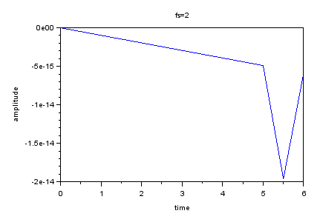

**## fs=4**

**fs=4**

**t=0:1/fs:2*%pi**

**x2=(A*sin (2*%pi*fa*t))**

**subplot (2,2,2)**

**plot (t, x2)**

**title ("fs=4")**

**xlabel ("time")**

**ylabel ("amplitude")**

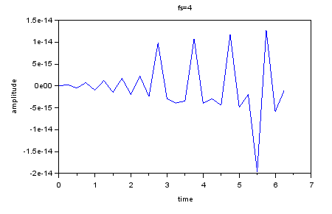

**## fs=8**

**fs=8**

**t=0:1/fs:2*%pi**

**x3=(A*sin (2*%pi*fa*t))**

**subplot (2,2,3)**

**plot (t, x3)**

**title ("fs=8")**

**xlabel ("time")**

**ylabel ("amplitude")**

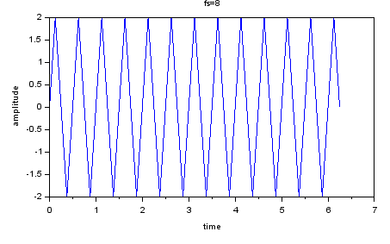

**## fs=16**

**fs=16**

**t=0:1/fs:2*%pi**

**x4=(A*sin (2*%pi*fa*t))**

**subplot (2,2,4)**

**plot (t, x4)**

**title ("fs=16")**

**xlabel ("time")**

**ylabel ("amplitude")**

